**CorpMQ Upgrade**

**for Cathay Pacific Airways Limited**



**RGP Proposal**

**28th dec, 2016**

TABLE OF CONTENTS

1. EXECUTIVE SUMMARY 4

2. CORPORATE PROFILE 5

2.1 RGP FINANCE & ACCOUNTING PRACTICE 5

2.2 INFORMATION MANAGEMENT PRACTICE 6

2.3 RGP PROGRAM & CHANGE MANAGEMENT APPROACH 7

2.4 PROGRAM MANAGEMENT APPROACH 7

2.5 CHANGE MANAGEMENT & USER TEAM BUY-IN 8

3. SCOPE OF WORK 10

3.1 OBJECTIVES 10

3.2 PROPOSD UPGRADE/MIGRATION APPROACH 10

3.2.1 RETAIN HARDWARE, OS, IP AND HOSTNAME CONFIGRATIONS 10

3.2.2 SYSTEM INTEGRATION test 11

3.2.3 FULL REGRESSION TEST 11

3.2.4 CODE CHANGES 11

3.2.5 PERFORMANCE TEST 11

3.2.6 ONE-OFF CUT OVER 11

3.3 DELEIVERABLES 12

4. PROJECT APPROACH 14

4.1 PROJECT INITIATION 14

4.2 MIGRATION PLANNING 15

4.3 MIGRATION IMPLEMENTATION 15

4.4 TESTING 16

4.5 DEPLOYMENT 17

5. PROJECT ASSUMPTIONS 18

6. PROJECT ORGANIZATION 19

7. PROJECT PLAN 21

8. INVESTMENT SUMMARY 22

8.1 PROFESSIONAL SERVICES 22

9. Critical Success Factors of this project 23

10. CLIENT SERVICE TEAM 26

PROPRIETARY AND CONFIDENTIAL MATERIAL

No part of this document may be reproduced by any means or transmitted without the written permission of Resources Connection, LLC, dba Resources Global Professionals (“RGP”) except with respect to copies made or transmitted internally for the purpose of evaluating this document.

This information is considered privileged and confidential, and its release would offer substantial benefit to competitors offering similar services. The material incorporated in this response includes descriptions of methodologies and concepts derived through substantial research and development efforts.

Therefore, it is the position of RGP that the use or release of the information contained in this document for purposes other than an evaluation of its contents as a basis for potential contract award is prohibited, and the materials herein are not considered subject to release under the Freedom of Information Act. All copies of this document and any accompanying electronic copies should, at RGP’s option, be returned to RGP or destroyed at the end of the document evaluation period if RGP is not selected. Other generally available marketing publications and materials provided with this document may be retained by Cathay Pacific Airways Limited (CX) for internal use.

Neither submission by RGP nor acceptance by CX of this proposal, in whole or in part, constitutes acceptance by RGP of any contractual terms contained in any CX request for proposal and shall not form a binding agreement between the parties. Such an agreement shall only exist upon the execution of a mutually acceptable contract by both CX and RGP.

Many elements of this response are dependent on assumptions that have been made by CX and RGP, and on the accuracy and completeness of information that has been provided to RGP but not yet verified. Accordingly, this response is subject to change and is based upon the verification of all such assumptions and information and the completion of due diligence with respect to the services contemplated to be performed.

1. EXECUTIVE SUMMARY

RGP would like to thank Cathay Pacific Airways Limited (“CX”) for having been granted the opportunity to response to the request for proposal for design, implementation and support services on its CorpMQ upgrade.

This proposal is based on the understanding from the information provided by CX during meetings with CX IT representatives.

Attempt will be made to cover all major relevant details, yet to present it as clear as possible. This will help to provide sufficient information for system professionals to use it as a basis for eventual deployment and also for management to decide on the investments.

RGP appreciates this opportunity to strengthen our business relationship with CX. RGP possess superior consulting, build and operate know-how and experience through large scale IBM Message Queue upgrade and migration projects for clients around the global and Hong Kong. We always help our customers to achieve business objectives.

Scope of work, project plan and price summary, to deliver the requested services, will be provided in this proposal. RGP is honor to provide the services to CX once the corresponding quotation is accepted.

1. CORPORATE PROFILE
   1. RGP FINANCE & ACCOUNTING PRACTICE

Since our founding in 1996, Finance & Accounting has been the central service offering of RGP, delivering interim and project-based services to small companies and large multi-national corporations across the globe. RGP’s Finance & Accounting services encompass accounting operations, financial reporting, internal controls, financial analyses and business transactions. Clients utilize our services to bring accomplished talent to bear on change initiatives as well as day-to-day operational issues.

Our professionals have successfully partnered with clients to address a wide variety of strategic and routine finance and accounting challenges. We have assisted clients with:

|  |  |
| --- | --- |
| * Re-engineering and transformational projects | * Shared services |
| * Offshoring and outsourcing | * Financial restatements |
| * Merger integration and related interim reporting | * Transaction due diligence |
| * Customer and product profitability analysis | * Business case development |

More routine assignments include: general accounting support and closing the books, accounting policy research and development, financial statement preparation including SEC Form 10-K and 10-Q, and general ledger account analysis and reconciliations.

The span of our Finance & Accounting services is depicted in the following table:

| FINANCE & ACCOUNTING EXPERTISE | |
| --- | --- |
| STANDARDS, PROCESS AND  SYSTEM IMPROVEMENT | * **Business Process Improvement** – Assess business processes and re-engineer for greater efficiency and/or improved controls. * **Financial Systems Life Cycle** – Assist across all phases of the Solution Lifecycle including stabilization, optimization, and transformation. * **Treasury Operations** – Development of investment, cash management and treasury policies and procedures, and prepare cash flow forecasts and various treasury reports. * **Skills Development/Training** – Improve awareness and competencies in accounting and Finance-related activities, including design and delivery of formalized training on specific accounting, financial or operational matters. |
| ACCOUNTING | * **Accounting Operations** – Performance of the day-to-day activities underlying accounting operations including transaction-level accounting, general ledger management and analysis, period-end closing process, consolidation and financial reporting. * **Technical Standards** – Research, policy development and application of accounting principles. * **Policies and Procedures** – Development, documentation and implementation of accounting policies and accounting procedures. |
| FINANCIAL REPORTING | * **External Financial Reporting** – Compilation, consolidation and reporting of external financial statements, including the preparation of regulatory filings. Streamline and automate the financial reporting process. * **Internal Management Reporting** – Compilation and consolidation of internal financial reports. * **Key Performance Indicators/Dash-Boards** – Development of management reports, such as key performance indicator reporting and pro-forma financial reporting. |
| FINANCIAL ANALYSIS | * **Financial Planning, Budgeting and Modeling** – Financial planning and budgeting, including development of the budgeting models, accumulation of the data and development of reports and presentations. * **Account and Transaction Level Analyses** – Detailed analysis of activities, trends and unexpected results at the account and class of transaction level. |

* 1. INFORMATION MANAGEMENT PRACTICE

RGP’s Information Management practice provides planning and execution services in the following primary areas: Program and Project Management, Business and Technology Integration, Data Strategy and Management, Information Management and Business Intelligence, and IT Strategy and Advisory. By focusing on the initiative as defined by our clients, RGP provides continuity of service from the creation or expansion of an overall IT strategy through post-implementation support. In addition to these services, we have expertise in a variety of technology solutions: Enterprise Resource Planning (“ERP”) systems; strategic “front-of-the-house systems”; human resources (“HR”) information systems; supply chain management systems; core finance and accounting systems; audit compliance systems; and financial reporting, planning and consolidation.

| RGP INFORMATION MANAGEMENT EXPERTISE | |
| --- | --- |
| PROGRAM AND PROJECT MANAGEMENT | * Program Management Office (PMO) * Project Management * Portfolio Rationalization * Project Recovery |
| BUSINESS TECHNOLOGY  ANALYSIS AND INTEGRATION | * Business Assessment and Strategy * Business Analysis and Process Improvement/Re-engineering * Change Management, Quality Assurance and Training * System Stabilization and Optimization |
| INFORMATION MANAGEMENT AND BUSINESS INTELLIGENCE | * System Assessment and Implementation * Business Intelligence (BI) and Reporting * Data Asset Management * Portals and Collaboration Systems |
| STRATEGY ADVISORY  AND TRANSFORMATION | * Strategic Planning/IT Strategy and Effectiveness * Organizational Design and Interim Management * IT Infrastructure, Architecture and Design Services * Capacity Planning * Capital Investment Analysis * IT Governance * IT Audit and Cyber Security * Disaster Recovery / Business Continuity Planning * Outsourcing and Shared Service Strategy * Lotus Notes Application Migration * IT Convergence Services |
| DATA STRATEGY AND MANAGEMENT | * Data Analysis * Data Conversion and Integration * Data Quality Management * Reporting Strategy and Development |

* 1. RGP PROGRAM & CHANGE MANAGEMENT APPROACH

RGP has provided program management expertise from creation through execution. We have served some of the largest organizations in the world, whether delivered as a stand-alone service to our clients, or provided as an internal value-add to ensure the quality of our services, timely completion and client satisfaction. Our team has developed the necessary project governance structures and managed complex global engagements including projects spanning over 50 countries with hundreds of team members running over multiple years. In servicing our clients, we provide experienced program managers / project managers to lead the day-to-day activities, with the support of our dedicated Client Service Team.

Our program management approach assumes that each client environment is unique. At RGP, we believe that one prescribed methodology does not fit all situations. Our Consultants bring exposure to a wide array of methodologies that you can draw from to determine what is best for your organization. We can then lead or augment internal teams to ensure projects are efficiently managed and successfully executed. Our priority is your success.

Clients engage us to guide them through the people aspects of their transformation initiatives. Activities such as stakeholder engagement, organizational design/alignment and implementation planning are key and vital activities to business transformation success. From our exposure to various methodologies, we have developed a change management framework that we adapt to your specific needs and culture. We call this our E3 (E Cubed) change management framework. This is a targeted approach, not a prescribed one, and is described in further section in this appendix.

* 1. PROGRAM MANAGEMENT APPROACH

Our approach provides practical information into specific key areas of program management best practices. In addition, it is independent to the methodology employed by CX, providing strategies and insight to common and important aspects of the program management discipline.

As depicted in the chart below, RGP’s *Approach, Roadmap, Templates* and *Examples* are all intended to be used in conjunction with CX’s program management methodology to enhance, accelerate, standardize, and facilitate project delivery.

The Methodology employed outlines the deliverables which are supported by the *Template* library. The *Approach* demonstrates strategies and best practices to develop the deliverables with the *Roadmap* showing the relationships of the three areas. The *Examples* demonstrate RGP real work experience. All the methods together make a robust and flexible strategy for quick wins, project delivery and integration with clients’ Change Management Office, if any.

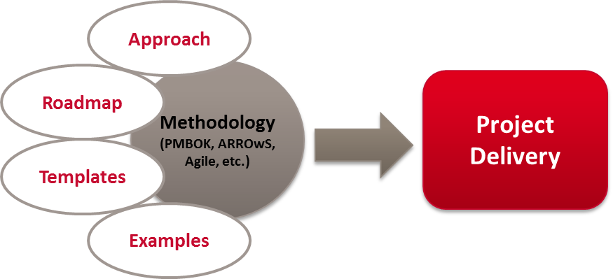

* 1. CHANGE MANAGEMENT & USER TEAM BUY-IN

RGP considers change management to be a vital aspect in the successful implementation of a transformation such as that contemplated by this initiative. Change management is a process for aligning and guiding management, project teams, and employees through the natural responses to significant organizational change. It is intended to accompany the implementation of new strategies, technologies, systems, processes, behaviors, and organizational structures; to capitalize on business opportunities and meet the changing demands of the business environment. It provides a set of key principles, a systematic framework, and tools that enable effective implementation. This may result in major alterations in organizational culture, employee competencies and attitudes, business capabilities, as well as alignment of organizational structure and work processes with corresponding strategies and capabilities.

RGP has partnered with hundreds of companies to minimize risks and disruptions during the execution of business transformation initiatives and ensure their changes result in sustained success. RGP’s change management framework is the basis for change, communication and training efforts we undertake in connection with all major client initiatives.

At a high level, we present our framework: **E3: Engage, Enable, Execute.**

* **ENGAGE.** Ongoing stakeholder communication to gain and maintain buy-in and support.
* **Identify Key Stakeholders.** Who needs to know what, when for maximum buy in and support.
* **Develop Key Messages.** Vision, case for change, selling points, personal impact, process/ timing, roles, progress, milestones.
* **Develop Engagement Plan**. Timing, vehicles/activities, feedback channels, spokespersons.
* **Deliver Communication.** Draft communication and disseminate according to plan.
* **ENABLE.** Organizational analysis and modification to enable and sustain change.
* **Identify Change Objectives.** Clarify goals of change effort and measures of success.
* **Evaluate Change Readiness.** Pinpoint and address potential change obstacles: cultural, operating model, skill gap, leadership support.
* **Identify Organizational Modifications.** Necessary role, process or structure change to enable and sustain successful change.
* **Implement Organizational Modifications.** Design or adjust roles, processes or structures.
* **EXECUTE.** Training and communication to ensure successful implementation.
* **Assess Stakeholder Impacts.** Identify training and communication needs related to role, process, structure, or strategy changes.
* **Develop/Deliver Training.** Targeted training to support skill development and adjustment to change.
* **Develop/Deliver Roll Out Communication.** Communication to ensure change is implemented with maximum acceptance and feedback is addressed.
* **Assess Outcomes.** Measure and assess outcomes against initial change objectives.

The methodology represents simple yet effective guidance to be utilized in its entirety as a standalone solution or as a supplement to a client’s existing methodology. Our professionals have utilized various methodologies throughout their careers and are flexible in adapting to an organization’s needs and cultures.

1. SCOPE OF WORK

## OBJECTIVES

Cathay Pacific has implemented IBM WebSphere Message Queue and relevant communication client applications for years. Due to the end of support of MQ version 6/7, the company has planned to kick start the MQ upgrade project from version 6 to version 8.

The objective of this project is aimed to ensure the smooth transitions of the mentioned middleware migration without affecting existing applications’ operations. To achieve this objective, RGP will work on the followings:

1. Conduct change analysis and planning on the CorpMQ upgrade
2. Design the new CorpMQ and setup it on IBM MQ 8
3. Migrate 100 queues from Fabric MQ to new CorpMQ
4. Plan and conduct unit test on the new CorpMQ
5. Plan and support full regression test (end-to-end testing) on the upgraded CorpMQ
6. Plan and conduct baseline performance test on the upgraded CorpMQ
7. Plan and support operational acceptance test (OAT) on the upgraded CorpMQ
8. Plan and support system cut-over
9. Produce operation manual on the new CorpMQ
10. Conduct maintenance transition to CX IT team
11. (Optional) Conduct code change on impacted CX applications which are using the CorpMQ

## PROPOSD UPGRADE/MIGRATION APPROACH

Based on our previous experience on MQ upgrade and migration and the understanding of CX’s requirements, we propose an approach with the following key characteristics.

## RETAIN HARDWARE, OS, IP AND HOSTNAME CONFIGRATIONS

To minimize the risk and impact on CX applications using the CorpMQ, we propose to have the upgraded CorpMQ setup in servers with the same configuration on hardware, OS, IP and hostname of the existing CorpMQ servers. With this approach, it shall minimize issues and errors on the connections between MQ clients and the upgraded CorpMQ.

## SYSTEM INTEGRATION test

Unit test will be planned and conducted to verify the correct setup of existing queues and queue managers in the upgraded CorpMQ. Dummy MQ clients will be developed to send and consume messages to and from the queues. The test will cover all possible types of MQ clients to send/consume messages. This test will be conducted by RGP project team and endorse the result by CX IT team.

## FULL REGRESSION TEST

Full regression test, on impacted CX applications, will be conducted to secure these applications are working properly after the CorpMQ upgraded. To success conduct the full regression test, testing scripts shall be prepared to verify application functions, which are using the CorpMQ, are working as designed. The test scripts shall either provided by application owner or application support team of CX. RGP project team will review the test scripts in order to prepare the upgraded CorpMQ for the full regression test. The full regression test will be conducted by CX application support team with the help of RGP project team to investigate the upgraded CorpMQ on any identified issues.

## CODE CHANGES

As there are feature changes between MQ version 6 to MQ version 8, e.g. channel authentication, etc., some of the MQ clients in the impacted applications may be required to have code changes in order to work properly with the upgraded CorpMQ. It is critical to assure the code changes can be implemented quickly and properly without impact the CorpMQ cut over date. RGP could provide programming resources to conduct the code changes together with CX application teams to speed up the code changes implementation. At the same time, RGP project team will support the regression test on changed applications.

## PERFORMANCE TEST

Performance test will be planned and conducted by RGP project team to verify the upgraded CorpMQ can be operating with performance as the current CorpMQ. It requires the support of CX IT team to provide baseline performance information, i.e. daily message handling capacity, of existing CorpMQ. RGP project team will use dummy MQ clients to send/consume messages to verify the capacity of the upgraded CorpMQ.

## ONE-OFF CUT OVER

An one-off cut over will be done to switch from existing CorpMQ to the upgraded CorpMQ for the impacted applications. Since the IP and hostname configurations of the upgraded CorpMQ are the same as the existing CorpMQ, there shall be no works required to be done on the impacted applications, which no code change is required, to switch over to the upgraded CorpMQ. The switch over action only requires to disconnect the existing CorpMQ from the network, and on the other-hands, connect the upgraded CorpMQ to the network. RGP project team will provide one week on-site stand-by to support the monitoring of the CorpMQ operation.

## DELEIVERABLES

Below table shows the deliverables proposed by RGP for each required service.

| **ID** | **Deliverable** | | **Table of Contents** |
| --- | --- | --- | --- |
| 1 | **Project Plan** – project team will follow this plan to design, develop, tests and migrate applications (include content) into the new application platform. *The project may be divided by phases to deliver applications by batches.* | * Project Objective * Project Approach * Project Schedule * Stakeholders * Resource Requirements * Project Controls * Project Organization * Project Communication * Risk Management * Change Management | |
| 2 | **System Design Specification –** allows infrastructure to refer to the system architecture, configurations and other design considerations for CX MQ migration. | | * System Consideration * System Architecture * MQSeries Specification * Interface Specification * Non-functional Design * MQSeries Sizing |
| 3 | **Migration Plan –** project team will follow this plan to migrate the CorpMQ objects from existing platform to the new platform. | | * Migration Approach * Strategy & Consideration * Migration Case Study & Preparation * Environments (Hardware, Software) * Queue Manager Cluster Migration * QM Migration Backout Procedure * MQ Instances Migration * MQ Instances Migration Blackout Procedure * Application Adjustment (CX Coordinated) * Instance Migration Backout Procedure |
| 4 | **Technical Specification –** allows setup support team and infrastructure team to understand the system’s detailed configuration for future setup, upgrade and maintenance activities. | | * Detail Architecture * Interface Technical Approach * Message Format * Message Descriptor * Message Expiration * Appendix – Channel Table Setup Procedure (MQSC) * Appendix – Cluster Setup Procedure (MQSC) |
| 5 | **System Test Plan** – allow testers to conduct functional test on the migrated platform. | | * Test Objective * Test Procedure * Test Schedule * Roles & Responsibilities * Resources * Test Cases |
| 6 | **System Integration Test Plan** – allow testers to conduct functional test and integration test on the migrated platform. | | * Test Objective * Test Procedure * Test Schedule * Roles & Responsibilities * Resources * Test Cases |
| 7 | **Performance Test Plan** – Performance test is an optional test. Only applications which expected to have large data volume and/or large concurrent users required to conduct load test against it. | | * Test Objective * Test Procedure * Test Schedule * Roles & Responsibilities * Resources * Test Cases |
| 8 | **System Test Report** – for verification of results of a system test. | | * Test Summary * Found Issues & Resolutions * Test Results * Conclusion |
| 9 | **System Integration Test Report** – for verification of results of a system integration test. | | * Test Summary * Found Issues & Resolutions * Test Results * Conclusion |
| 10 | **Performance Test Report** – for verification of results of a performance test. | | * Test Summary * Found Issues & Resolutions * Test Results * Conclusion |
| 11 | **Deployment Manual** - details of the deployments steps, checks points, roll back procedures, with deployment scripts as appendix. | | * Deployment procedure * Deployment Steps * Fall Back Plans |

1. PROJECT APPROACH

Our project approach will be tailored to meet Cathay Pacific’s specific objectives and operating preferences. We will leverage our extensive expertise and experience with similar initiatives, and propose to execute this initiative in five steps:

1. Project Initiation
2. Migration Planning
3. Migration Implementation
4. Testing
5. 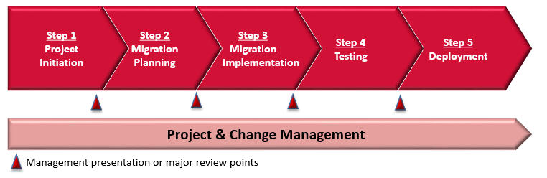Deployment

## PROJECT INITIATION

**Step 5**

**Deployment**

**Step 4**

**Testing**

**Step 3**

**Migration Implementation**

**Step 2**

**Migration Planning**

**Step1**

**Project Initiation**

|  |  |
| --- | --- |
| Step | **Step 1 – Project Initiation** |
| Objective | * To Study and Identify Technical Dependency on Critical Business Applications and Infrastructure * To Determine Current Recovery Time of Critical Business Applications and Infrastructure * To Identify Relationship Between Critical Business Processes and Applications and Infrastructure |
| Key Activities | * Identify Key Stakeholders of All Related Channels * Compile Dependency Matrix on Critical IT systems * Form Project Team |
| Deliverables | * Project Plan * Project Schedule * Project Approach * Project Organization * Project Communication Plan |

## MIGRATION PLANNING

**Step 5**

**Deployment**

**Step 4**

**Testing**

**Step 3**

**Migration Implementation**

**Step 2**

**Migration Planning**

**Step1**

**Project Initiation**

|  |  |
| --- | --- |
| Step | **Step 2 – Migration Planning** |
| Objective | * To Identify New Requirements/Changes on New Features (Optional) * To Investigate interfaces specification of all endpoints/clients, in order to come up a less risky planning to * To Identify Housekeeping Processes in Existing Middleware * To Facilitate and Development Team to Complete PoC on New Version of MQ Clients connection * To Conduct Design on New CorpMQ Environment |
| Key Activities | * Work Closely with Middleware Team to Study Technical Documents or Operation Manuals of existing Middleware * Collect and Study the Interface Documents of the Client Applications * Provide Support to Application Development Team to Conduct the PoC * Document Architecture and Configuration |
| Deliverables | * System Design Specification * Technical Specification * Migration Plan |

## MIGRATION IMPLEMENTATION

**Step 5**

**Deployment**

**Step 4**

**Testing**

**Step 3**

**Migration Implementation**

**Step 2**

**Migration Planning**

**Step1**

**Project Initiation**

|  |  |
| --- | --- |
| Step | **Step 3 – Migration Implementation** |
| Objective | * To Implement the new CorpMQ according to the System Design |
| Key Activities | * Implement and Configure Queue Clustering * Implement and Configure Remote and Alias Queues * Implement and Configure Queue Channels * Conduct Connectivity Tests * Conduct Checkpoint Meetings |
| Deliverables | * New CorpMQ Servers * System Test Report |

## TESTING

**Step 5**

**Deployment**

**Step 4**

**Testing**

**Step 3**

**Migration Implementation**

**Step 2**

**Migration Planning**

**Step1**

**Project Initiation**

|  |  |
| --- | --- |
| Step | **Step 4 – Testing** |
| Objective | * To verify the upgraded CorpMQ is configured and working properly * To verify impacted applications are working as designed with the upgraded CorpMQ * To modify impacted applications to work as designed with the upgraded CorpMQ, if required * To verify the upgraded CorpMQ has performance as the current CorpMQ * To confirm the upgraded CorpMQ is ready for production |
| Key Activities | * Produce System Integration Test (SIT) Plan and Test cases * Support Acceptance Test * Conduct SIT with dummy MQ clients * Support Full Regression Test on Impacted Applications * Support system acceptance OAT * Fix Any Issues Identified during SIT * Fix Any Issues identified during Full Regression Test * Fix Any Issues Identified during OAT * Implement Code Changes on Impacted Application, If Any * Monitor the Stability, Performance and Issues of MQ Server During the Testing * Produce SIT report * Produce Performance Test report |
| Deliverables | * SIT Test Report * Performance Test Report |

## DEPLOYMENT

**Step 5**

**Deployment**

**Step 4**

**Testing**

**Step 3**

**Migration Implementation**

**Step 2**

**Migration Planning**

**Step1**

**Project Initiation**

|  |  |
| --- | --- |
| Step | **Step 5 – Deployment** |
| Objective | * To Switch Over from Existing CorpMQ to the Upgraded CorpMQ * To Monitor and Assure the Proper Operation of the Upgraded CorpMQ and Impacted Applications during the Nursing Period * To Transfer the Maintenance and Operation of the Upgraded CorpMQ to CX IT Team |
| Key Activities | * Plan Cut Over of the CorpMQ * Conduct and Coordinate Cut Over of the CorpMQ * Monitor the End-to-End Processing of the Upgraded CorpMQ * Support Fixing of Any Issues after Cut-Over during the Nursing Period * Knowledge Transfer on Maintenance of the Upgraded CorpMQ |
| Deliverables | * Deployment Manual |

1. PROJECT ASSUMPTIONS

We are committed to exceeding CX’s standards, criteria, timing and objectives for the restructuring. Our delivery of such is based on the extent to which project phases can be done in parallel and, furthermore, the following Assumptions. Delays and/or an inability to meet any of the requirements described in these Assumptions will impact project schedule, deliverable timing and respective fees:

* Approximate 130 CX applications are using the CorpMQ.
* Approximate 100 queues will be migrated from existing Fabric MQ to the upgraded CorpMQ. Around 3 CX applications are using this queues. CX will provide details on these queues and applications for RGP to conduct migration planning and system design.
* CX Application Support Team will conduct the full regression test and prepare the corresponding test scripts. RGP only support the investigation and fixing on any identified deflects on the upgraded CorpMQ.
* CX will provide access to its premises for RGP to perform its obligations.
* CX will provide adequate facilities, equipment and tools (such as computers, printers, offices, telephones, photocopiers, fax machines, and voice and electronic mail) for the team members and Consultants who work onsite.
* A detailed project plan will be finalized, confirming the scope, level of effort, timing and resource requirements by the end of project scoping and planning phase and determine any change in estimated hours.
* During the project, tasks outside of scope will be identified and agreed upon. If the project scope changes, the skill set may be adjusted and the fees will be adjusted accordingly. Required changes will be communicated during the project lifecycle.
* Information required by the team from organizations or individuals within CX will be provided in a timely manner consistent with the work plan.
* At the onset of the engagement and throughout the project, CX will provide, on a timely basis, relevant and necessary documentation, which will include, but not be limited to, existing analyses, assessments, research and materials already collected.
* RGP will have access to all previously completed deliverables related to past relevant projects, as needed.
* The Project Consultants will require timely involvement and interactions with CX’s personnel to complete the project.
* CX will designate a Project Sponsor with the ability and authority to provide project oversight, resolve issues when escalated, and make timely decisions and commitments.
* Project deliverables will be submitted to the CX Project Sponsor(s) or designee for approval. CX will review and approve/reject deliverables within a reasonable timeframe, unless otherwise agreed. Acceptance of deliverables will also be verified in project status reports.

1. PROJECT ORGANIZATION

To success deliver the requested services, we proposed the following team structure:

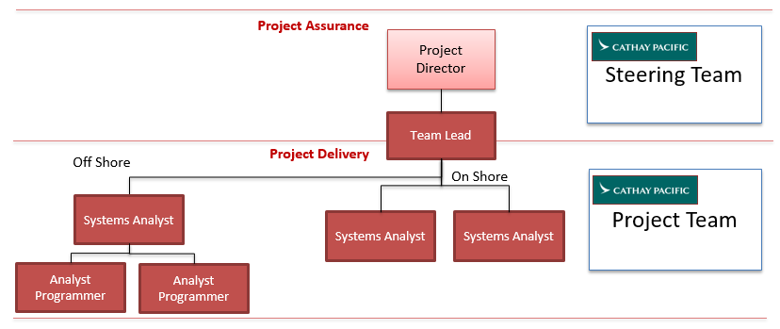

|  |  |
| --- | --- |
| **Role** | **Responsibility** |
| **Team Lead** | Closely working with the CX Project Manager and Project Team, the Team Lead is the lead Consultant who will be responsible for the overall communication, project planning and progress monitoring. In our proposal, the presented project manager will have strong Notes and SharePoint technical knowledge and project management background. He will lead the delivery of the key deliverables in the consultancy service for new platform architecture and migration strategy. |
| **Systems Analyst** | The System Analyst plays a key role working with CX IT team to identify and confirm requirements, and will take the lead in migration plan and system design specifications. He or she will be responsible to the setup and integration test of the upgraded CorpMQ. |
| **Analyst Programmer** | The Analyst Programmer will be responsible to prepare detailed technical specification, prepare test cases and conduct system test. He/she will also support the fixing of issues identified during the system test. |

We are pleased to present a Delivery Team comprising the following Consultants.

| **CONSULTANT** | **ROLE** | **CONSULTANT BIO** |
| --- | --- | --- |
| ***Edward Leung*** | Team Lead | Over 20 years of Information Technology experience with over 10 years in a project management role. Experiences in different middle-tier projects and other related IT projects for banks and financial institutions. |
| ***Tommy Leung*** | On Shore Systems Architect 1 | Over 14 years of experience in development of complex business applications and system design in banking industry.  Hands on experience in MQ applications deployment and server migrations with strong Business knowledge on Electronic Banking System, Funds Investment System, or Insurance System. |
| ***Eric Oei*** | On Shore System Analyst 2 | Over 15 years of Information Technology experience with over 10 years in a system analyst role.  Proficient in leading the development team on gathering and analyzing user requirements, evaluating implementation options, performing system sizing, calculating costs and benefits, producing documentation as well as physical and interfaces design and specifications. |
| ***Lotic Lin*** | Off Shore System Analyst 1 | With 9 years of software industry experience. 5 year experiences in Java design and E-commerce platform technology framework.  Excellent team leadership and influence. |
| ***Parko Lam*** | Off Shore Analyst Programmer 1 | Over six years of experience in project management. Experienced in project planning, system design, development and implementation.  Intensive experience in Government, Retails and Education industries. |
| ***Benjamin Cai*** | Off Shore Analyst Programmer 2 | With 3 years working experience in JAVA, participating in most of the major project development and requirements analysis.  Familiarity with OOP object-oriented programming, with a solid programming skills and good habits of coding, comments. |

1. PROJECT PLAN

Based on our previous experiences, our estimated timeline to complete this initiative is presented below. The RGP resources needed are also projected.



**Remarks:**

It is proposed to complete project in 40 weeks of time.

1. INVESTMENT SUMMARY

## PROFESSIONAL SERVICES

The estimated cost for the professional services for the required services is listed below.

1. **CorpMQ Upgrade and FabricMQ Migration to CorpMQ**

|  |  |  |  |  |
| --- | --- | --- | --- | --- |
| **ID** | **Role** | **Total Hours** | **Hourly Rate (HK$)** | **Sub-Total (HK$)** |
|  | | | | |
| 1 | **Team Lead** | 584 | 560 | 327,040.00 |
| 2 | **System Analyst – On Shore** | 2732 | 510 | 1,393,320.00 |
| 3 | **Systems Analyst – Off Shore** | 636 | 460 | 292,560.00 |
| 4 | **Analyst Programmer – Off Shore** | 1808 | 300 | 542,400.00 |
| **Total** | | | | **2,555,320.00** |
|  | | | | |

1. ***Optional*: Code Change for Impacted Applications**

|  |  |  |  |  |
| --- | --- | --- | --- | --- |
| **ID** | **Role** | **Total Hours** | **Hourly Rate (HK$)** | **Sub-Total (HK$)** |
|  | | | | |
| 1 | **Team Lead** | 160 | 560 | 89,600.00 |
| 2 | **System Analyst – On Shore** | 560 | 510 | 285,600.00 |
| 3 | **Systems Analyst – Off Shore** | 560 | 460 | 257,600.00 |
| 4 | **Analyst Programmer – Off Shore** | 1280 | 300 | 384,000.00 |
| **Total** | | | | **1,016,800.00** |
|  | | | | |

1. MQ Upgrade/Migration Case Sharing

|  |  |
| --- | --- |
| **CASE 1** | |
| **CLIENT** | China Construction Bank (Asia) - CCBA |
| **INTIATIVE** | **MQ Upgrade and Performance Tuning** |
| **CHALLENGE** | CCBA has implemented a complicated routing business logic into the message broker. The performance is difficult to spot in different channels. |
| **HOW WE HELPED** | We have conducted the performance evaluation of existing architecture based on WebSphere MQ, Message Broker and Application Server. During the period, we took part in the architecture and system design for the new MQSeries for security trading, satisfying high traffic volume support up to 100 TPS with synchronized response, with Load balancing and HA. We deployed MQ clients implementation guideline for other vendors to ensure end-to-end implementation and provided pilot testing cases and performance test guidelines for SIT. |

|  |  |
| --- | --- |
| **CASE 2** | |
| **CLIENT** | HSBC Private Bank |
| **INTIATIVE** | **Application Evergreening** |
| **CHALLENGE** | The infrastructure need to be upgraded according to hardware / middleware support cycle. |
| **HOW WE HELPED** | We have setup a new infrastructure and install the application into it. The application is modified according to the change and support during the regression cycle. |

1. Critical Success Factors of this project
2. A one page explanation on how the proposed solution will differentiate the tenderer from other tenderers and why CX should choose the tenderer as the award tenderer.

Throughout this document, we discuss the RGP value proposition, which consists of customized professional services and solutions, delivered by highly-experienced and credentialed Consultants under a flexible, client-centric business model. As we understand CX’s requirements, our value proposition translates to the following critical elements:

***IBM MQ Upgrade/Migration Projects Experience*.** RGP has assisted a wide array of clients with IBM MQ Upgrade/Migration Project(s), including the development, assessment, and migration of MQ and review of recovery capabilities of key applications and required business functions and processes. As described in previous sections, we have assembled an exceptional team of highly experienced Consultants, all with relevant experience in IBM MQ Upgrade/Migration projects like CCBA and HSBC. With the team ready for engagement we are capable and well positioned to successfully execute this project.

***RGP Consultants and Client Service Team****.* Our Information Management practice is comprised primarily of project managers and business analysts that have both technical and functional skills. With an average of 15+ years of relevant experience with the Big Four and/or Fortune 500 companies, our Consultants have worked on multiple initiatives similar to CXs. Our CX’s Client Service representative remains committed throughout the engagement at no additional cost. The combination of highly-relevant, deep experience and our collaborative teaming model ensures that your team will be able to learn from ours.

***Our approach and methodology will be tailored to CX specific needs.*** Over their years of experience, our Consultants have worked with a myriad of methodologies and approaches to plan, execute and sustain business initiatives. Our expertise lie not in implementing a single pre-determined formula, but in collaborating with our client to truly understand their needs and ensure we reach alignment on the identification of needs and approach for successfully meeting them together. We are also well qualified to lead initiatives and provide thought leadership at your discretion.

***Unbiased Approach.*** RGP is hardware and software agnostic – we are unbiased and objective when evaluating a client’s needs in relation to a system’s strength. Our clients benefit from our extensive and comprehensive selection, implementation and change management experience, which spans a very wide range of tools, industries and business functions.

***Fees***. Our fees, as requested are summarized in Section 7. We are confident that the combined value of our Consultants’ experience, efficiency, ability to transfer knowledge, and our frequently unbilled client service and subject matter expert support, result in a value proposition that far exceeds any competing offer. When combined with the complete range of services RGP can leverage in support of this project, and our seamless one-firm delivery model, we believe we are uniquely positioned to achieve the results CX is seeking.

***RGP’ commitment to cost containment****.* The current global economy has placed unusual pressure on all of our businesses, and RGP is committed to being a part of our clients’ overall cost containment strategy. As such, we believe the following aspects of our model drive low total-cost-of-ownership solutions without compromising on quality or results.

* Consultants average over 10+ years of relevant experience; they are immediately effective and efficient;
* Local Client Service Directors partner-level support is frequently provided at no additional cost;
* Local Consultants are engaged whenever possible to minimize expense;
* Regular checkpoint meetings project, manage and control costs;
* We manage our Consultants diligently to ensure personnel are rolled-off when no longer required; and,
* We never bill “administrative fees”, a common practice of the Big Four consulting firms.

Again, RGP greatly appreciates CX’s consideration of this proposal, and we look forward to further dialogue regarding this initiative.

1. The unique features that give the tenderer’s company a competitive edge in market.

The following chart provides an overview of the differences between RGP and traditional consulting and staffing firms:



--- End of Document ---

1. CLIENT SERVICE TEAM

All CX engagements will be executed under the management and support of a dedicated Engagement Team. The RGP Engagement Team is comprised of our Client Service Team and our Delivery Team, supported by our Centers of Expertise. Refer below for a graphical representation of our Engagement Team.

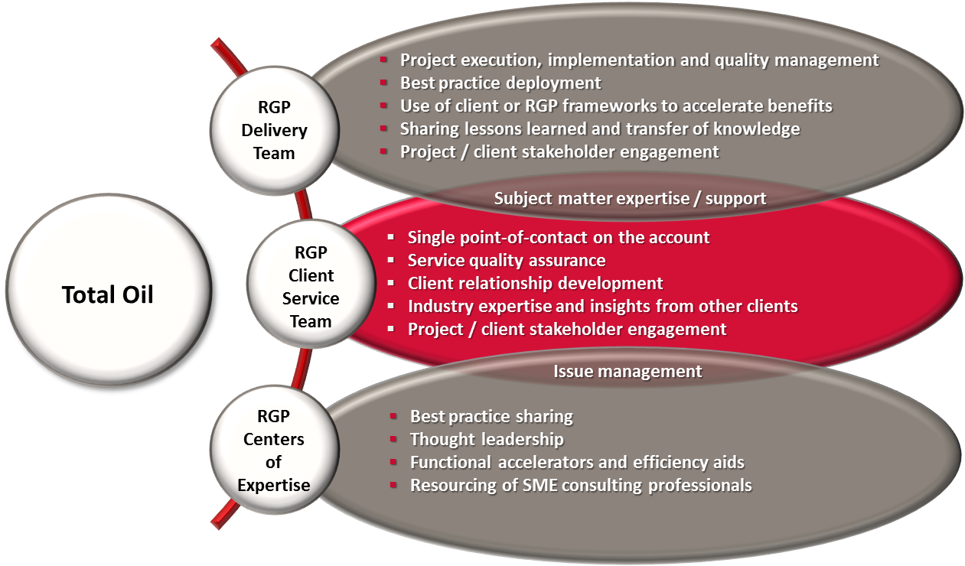

CX

RGP CLIENT SERVICE TEAM

Our Client Service Team will ensure all planning and execution is coordinated globally and executed locally. Throughout the life of each project, the RGP Client Service Team will monitor the performance of our project teams, engage in regular communication with CX and address all feedback. In addition to interfacing with the client, the Client Service Team leads an internal RGP team that provides as-needed support to our engaged teams. Such support can include specific subject matter expertise, best practices, and/or additional quality assurance elements. ***Notably, the support of the Client Service Team is provided to our clients on an unbilled basis.***

For this relationship, the CX Client Service Team role will be fulfilled by:

AARON LEE – Director INFORMATION MANAGEMENT, HONG KONG  
Hong Kong

Aaron has more than 18 years of experience in IT, specializing in managing consulting services and enterprise system solutions implementation. He came to RGP from Atos Hong Kong where he was most recently the General Manager of Consulting and System Integration, after heading up Atos' Technical Consulting for a couple of years. Before Atos, Aaron ran consulting services for Fusion System, served as Technology Specialist Lead at Microsoft Hong Kong, and served as a Senior Consultant at Sybase. Aaron holds a Bachelor's degree with Honors in Information Systems from Staffordshire University (UK). Aaron's domain expertise includes business process re-engineering, IT strategic planning and enterprise solution implementation. He is also a pioneer in exploring e-business and e-government solutions, fostering strategic alliances with technology vendors throughout Asia Pacific. **Aaron will be the central point of contact and service for CX, responsible for monitoring the progress of the project and Consultant performance.**

ELAINE CHEUNG – Director FINANCE & ACCOUNTING / RISK & COMPLIANCES  
Hong Kong

Elaine is a qualified accountant with professional and commercial experience in both Hong Kong and Australia. She came to RGP from Ernst & Young where she spent almost 5 years in her last position as Senior Manager in Transactions Advisory Services, responsible for insolvency, restructuring, forensic investigation and corporate finance initiatives. Prior to E&Y, Elaine had worked for several professional and corporate advisory services firms on a variety of analytical reviews on financial statements, strategic diagnostic reviews, insolvent administrations, forensic investigations and corporate restructuring. Elaine holds a Bachelor degree in Economics (majoring in Accounting & Economics) from the University of New South Wales, Australia. She is also a qualified CPA, Insolvency Practitioner in Australia and is a holder of Specialist Designation in Restructuring & Insolvency.

SIMON KONG – MANAGING Director, HONG KONG  
Hong Kong

Simon has over 18 years of Information Management experience across industries and has led multiple consulting projects on business process transformation, shared service / BPO assessment and transition, and ERP systems implementation for RGP's clients since he joined the company in 2007. Prior to joining RGP, Simon was a Managed Services Account Executive with Computer Sciences Corporation (CSC) where he was responsible for managing regional accounts including client relationship and P&L, and leading a team of Project Managers and IT professionals to deliver professional services for global clients. Prior to CSC, Simon held a number of IT management positions at Sun Microsystems Inc. where he ran various global and regional projects on process improvement, organization transformation, and business solution implementation both within IT and across business units.